

**Git use step-by-step instructions – Code Voyayers**

**Steps at the beginning of a project**

**Preliminary steps**

**Install Git locally**

Create Github repository and add collaborators

Create main and develop branches locally and push first commit

Create Github project

**Install Visual Studio Code locally**

**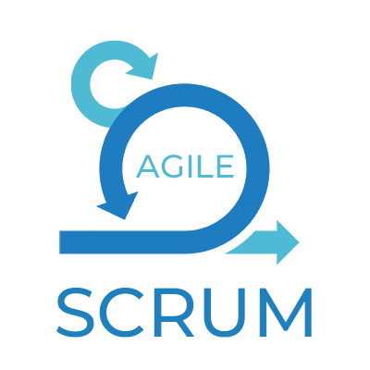***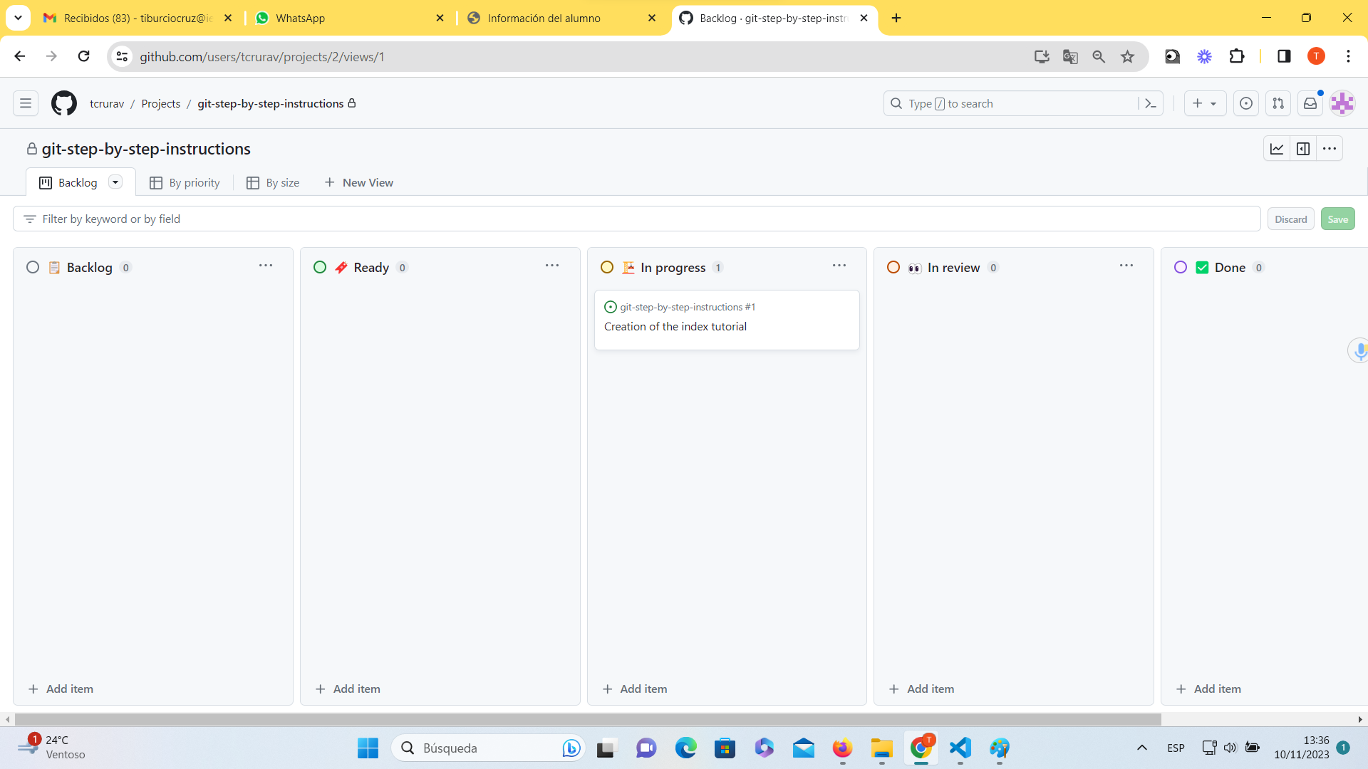*

Create Github rules

Create a folder for a local Visual Studio Code project

Drag ítems to Ready column

Create pull request for issue#n

Create new local branch with name issue#n from develop

Working on issue#n

Push to remote branch issue#n

Drag ítems into In progress column

Merge into develop from issue#n

**Steps to review a pull request**

Same steps 18 to 20 but now to merge from develop to main

Merge into develop from issue#n

**Steps in Github to merge**

Assign issue to developer

Convert ítem in issue

Assign repository to item

**Steps developing an issue**

**Steps during Scrum sprint design**

Add items to Backlog at any time

**Steps all along the project**

**Create Github account**